**PRACTICAL 6**

**Network Virtualization (Sending Data of 2 LAN’s from single data-link)**

**Aim –** Create a LAN network with 4 PC’s and 2 switches. Using network virtualization create two VLAN’s of two PC’s from one physical LAN’s.

**Topology –**

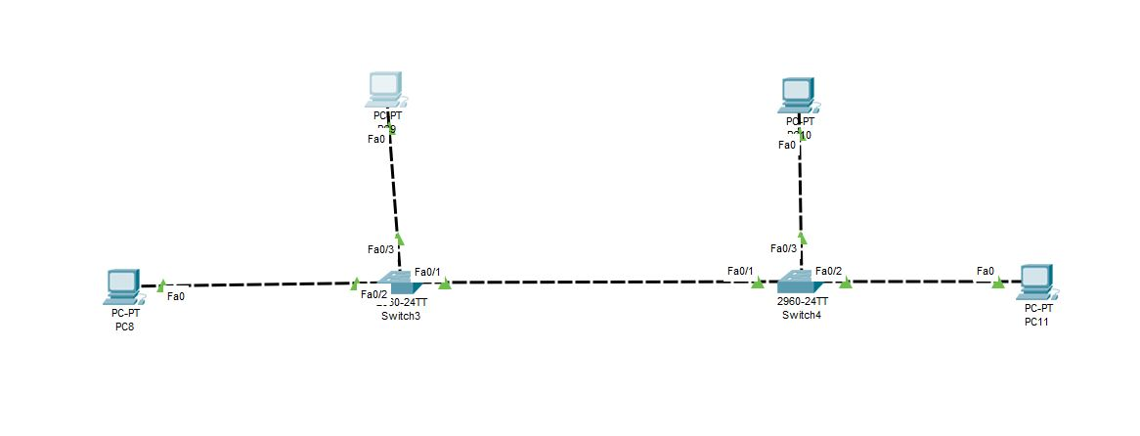

**Steps –**

*Step 1: Create Topology as shown above but do not assign the IP address to the PC.*

*Step 2: Start CLI for Switch and create tow vlans vlan red and vlan blue.*

**Syntax for creating VLAN:**

**vlan v_number**

**name v_name**

**Switch 1:**

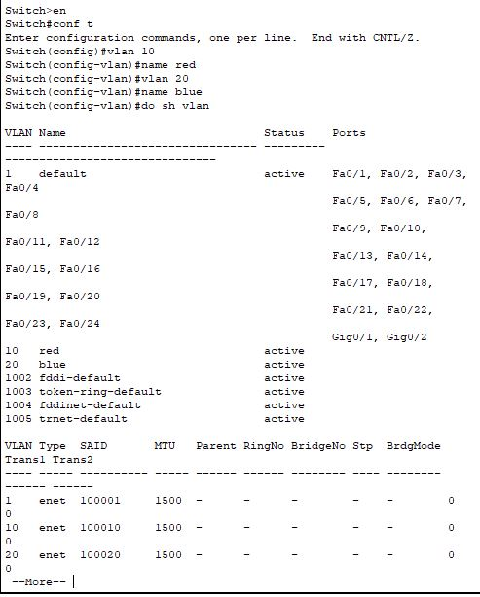

**Switch 2:**

**

*Step 3: Now, start adding the PC’s to specific vlan*

**Switch 1:**

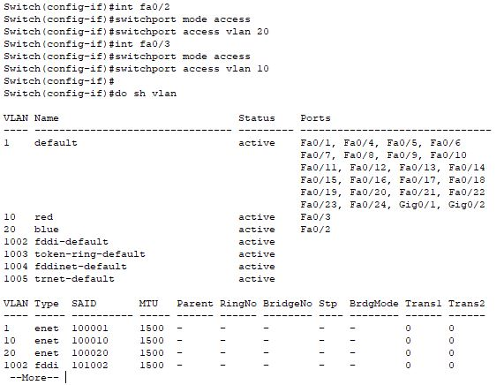

**To send the data of two VLAN’s from one link we use mode as *TRUNK***

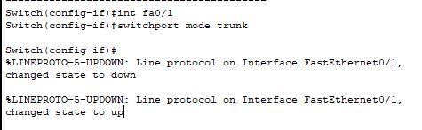

**Switch 2:**



**To send the data of two VLAN’s from one link we use mode as *TRUNK***



*Step 4: Now, When we will ping the PC’s from same VLAN they should give reply and for PC’s from different VLAN they won’t reply.*

**Same VLAN’s**

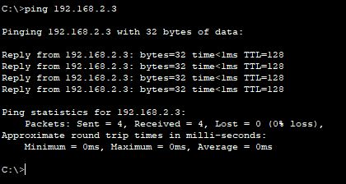

**Different VLAN’s**

